**Detailed Business Specific Requirements:-**

**Theme**: Existing IT system for internal agencies of MoJS

**Applications**: WIMS expansion-WRIS

**Use Cases:-** Jal-ltihaas-**WRIS-SSA-07**

**Other linked Use Case :-** N/A

**Description**:-

Water heritage structures are a vital component of India's rich cultural heritage. The deep understating of its significance need to established to preserve the water heritage structures exist in the country.The geo-mapping of the water heritage sites could lead to create an inventory of these structures to gain a comprehensive overview of the state of water conservation and augmentation in the country which can ensure the availability of the heritage sites information to the future generation.

**Reframe**:-

Water heritage structures play a crucial role in India's diverse cultural heritage. It is essential to deepen our understanding of their importance in order to preserve these invaluable sites. By geo-mapping water heritage locations, we can create a comprehensive inventory that provides insight into the current state of water conservation and enhancement across the country. This initiative will help ensure that information about these heritage sites is accessible to future generations.

**Use Case:-**

#### 1. Actors

* Government Agencies: Responsible for cultural heritage and water conservation.
* Local Communities: Stakeholders who live near water heritage sites and can provide local knowledge.
* Researchers/Academics: Individuals or institutions studying water heritage and conservation.
* NGOs/Environmental Organizations: Groups focused on heritage preservation and environmental sustainability.
* Technology Providers: Companies or organizations that provide geo-mapping and data management solutions.

#### 2. Main Flow

1. Initiation: Government agencies identify the need to preserve water heritage structures and initiate a geo-mapping project.
2. Stakeholder Engagement: Local communities, researchers, and NGOs are engaged to gather insights and support for the project.
3. Data Collection: Teams conduct field surveys to collect data on existing water heritage structures, including their locations, conditions, and historical significance.
4. Geo-Mapping: Collected data is input into a geo-mapping software to create a digital inventory of water heritage sites.
5. WIMS expansion-WRIS
6. Analysis: Researchers analyze the data to assess the current state of water conservation and identify areas needing attention.
7. Reporting: A comprehensive report is generated, detailing the findings and recommendations for preservation and conservation efforts.
8. Public Access: The geo-mapped inventory is made available to the public, ensuring future generations can access information about these heritage sites.

#### 3. Alternative Flow

* Data Inaccuracy: If data collected during field surveys is found to be inaccurate, additional surveys may be conducted to verify and correct the information.
* Community Resistance: If local communities are resistant to the project, additional outreach and education efforts may be implemented to explain the benefits of preserving water heritage structures.
* Technological Challenges: If there are issues with the geo-mapping technology, alternative methods (e.g., manual mapping) may be employed until the technology is resolved.

#### 4. Benefits

* Preservation of Cultural Heritage: Ensures that water heritage structures are documented and preserved for future generations.
* Enhanced Water Conservation: Provides a comprehensive overview of water conservation efforts, helping to identify areas for improvement.
* Community Engagement: Involves local communities in the preservation process, fostering a sense of ownership and responsibility.
* Educational Resource: Creates a valuable resource for researchers, students, and the public to learn about India's water heritage.

#### Pre-Conditions

* Government support and funding for the geo-mapping project.
* Collaboration and willingness from local communities and stakeholders.
* Availability of technology and expertise for geo-mapping.

#### Post-Conditions

* A comprehensive digital inventory of water heritage structures is created and accessible to the public.
* Increased awareness and understanding of the importance of water heritage among communities and stakeholders.
* Established frameworks for ongoing monitoring and preservation efforts of water heritage structures.

**Summary:-**

Water heritage structures are integral to India's cultural heritage, necessitating a deeper understanding for their preservation. A geo-mapping initiative can create a detailed inventory of these sites, offering insights into the current state of water conservation and ensuring that information remains accessible for future generations. Key actors in this process include government agencies, local communities, researchers, NGOs, and technology providers. The main flow involves initiating the project, engaging stakeholders, collecting and analyzing data, and making the findings publicly available. Alternative flows address potential challenges such as data inaccuracies, community resistance, and technological issues. The benefits of this initiative include the preservation of cultural heritage, enhanced water conservation, community engagement, and the creation of educational resources. Successful implementation requires government support, collaboration from local stakeholders, and access to necessary technology, ultimately leading to a comprehensive digital inventory and increased awareness of water heritage's significance.

**Figure_001_intro_Use-case_PlantUML_diagram:-**

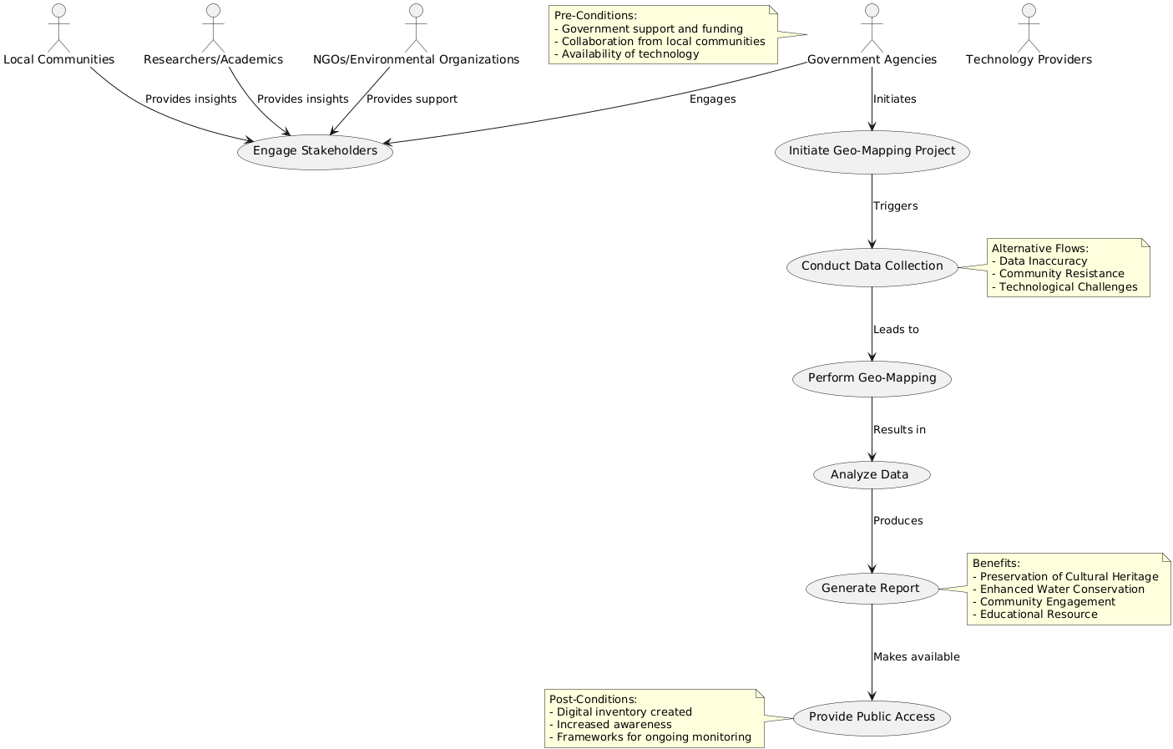

**Figure_001_intro_Use-case_PlantUML_code:-**

@startuml

actor "Government Agencies" as GA

actor "Local Communities" as LC

actor "Researchers/Academics" as RA

actor "NGOs/Environmental Organizations" as NGO

actor "Technology Providers" as TP

usecase "Initiate Geo-Mapping Project" as UC1

usecase "Engage Stakeholders" as UC2

usecase "Conduct Data Collection" as UC3

usecase "Perform Geo-Mapping" as UC4

usecase "Analyze Data" as UC5

usecase "Generate Report" as UC6

usecase "Provide Public Access" as UC7

GA --> UC1 : Initiates

GA --> UC2 : Engages

LC --> UC2 : Provides insights

RA --> UC2 : Provides insights

NGO --> UC2 : Provides support

UC1 --> UC3 : Triggers

UC3 --> UC4 : Leads to

UC4 --> UC5 : Results in

UC5 --> UC6 : Produces

UC6 --> UC7 : Makes available

note right of UC3

Alternative Flows:

- Data Inaccuracy

- Community Resistance

- Technological Challenges

end note

note right of UC6

Benefits:

- Preservation of Cultural Heritage

- Enhanced Water Conservation

- Community Engagement

- Educational Resource

end note

note left of GA

Pre-Conditions:

- Government support and funding

- Collaboration from local communities

- Availability of technology

end note

note left of UC7

Post-Conditions:

- Digital inventory created

- Increased awareness

- Frameworks for ongoing monitoring

end note

@enduml

**Figure_002_intro_Use-case_Notegpt_diagram:-**

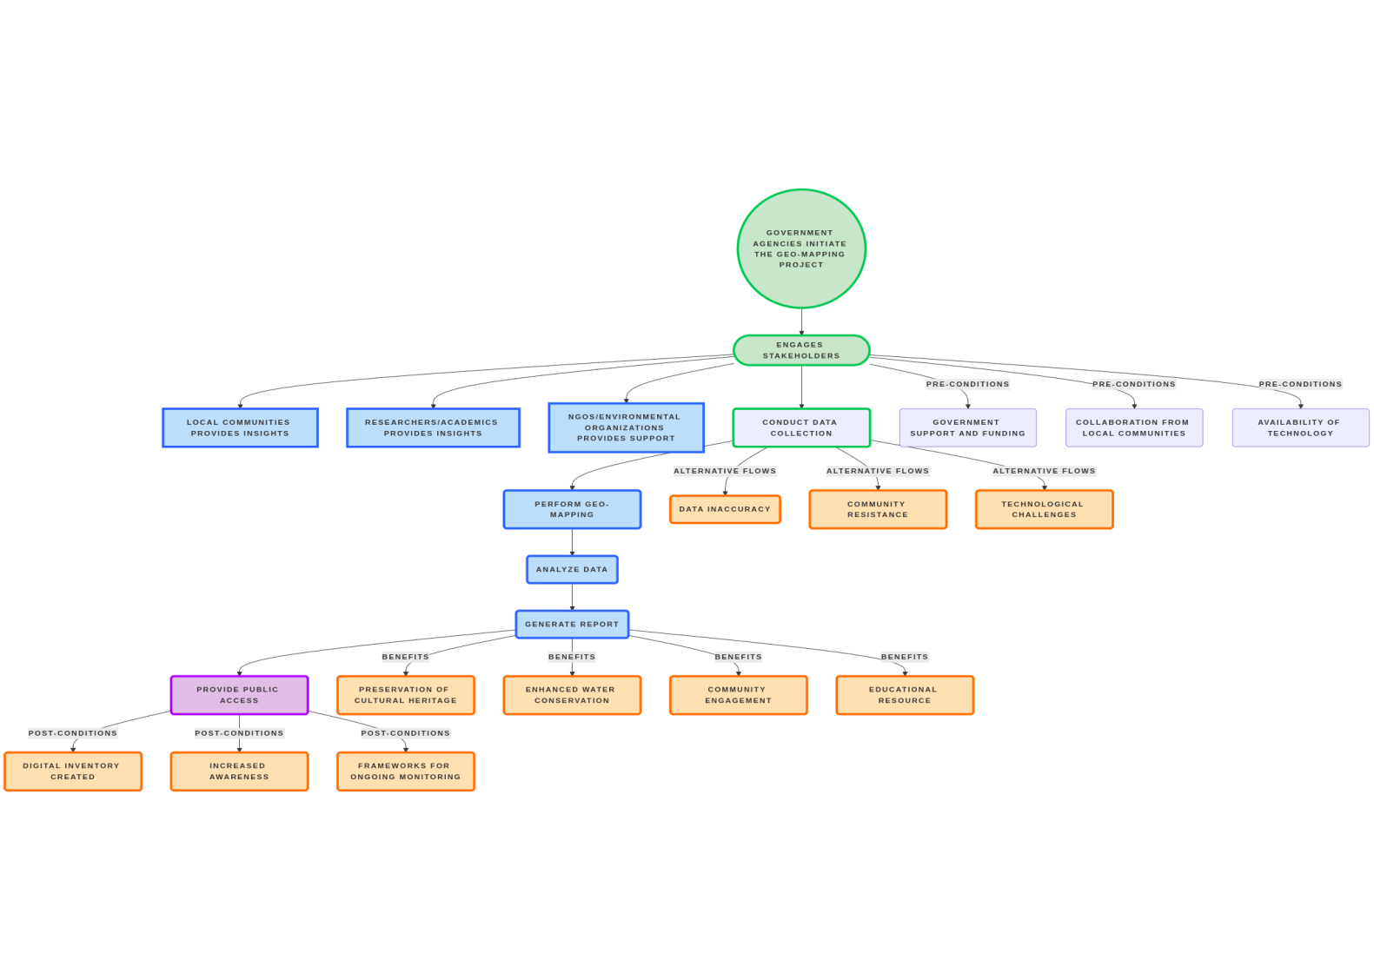**Figure_002_intro_Use-case_Notegpt_code:-**

@startuml

actor "Government Agencies" as GA

actor "Local Communities" as LC

actor "Researchers/Academics" as RA

actor "NGOs/Environmental Organizations" as NGO

actor "Technology Providers" as TP

usecase "Initiate Geo-Mapping Project" as UC1

usecase "Engage Stakeholders" as UC2

usecase "Conduct Data Collection" as UC3

usecase "Perform Geo-Mapping" as UC4

usecase "Analyze Data" as UC5

usecase "Generate Report" as UC6

usecase "Provide Public Access" as UC7

The frequency of updates is inherently static, meaning that the data will not change on a regular schedule. Instead, updates will occur based on the availability of new information.

This approach allows for a more flexible and responsive system, ensuring that the data remains relevant and accurate as new insights or information become accessible.

While users can expect a consistent baseline of information, they should also be aware that updates will be implemented as opportunities arise, enhancing the overall quality and reliability of the data provided.

GA --> UC1 : Initiates

GA --> UC2 : Engages

LC --> UC2 : Provides insights

RA --> UC2 : Provides insights

NGO --> UC2 : Provides support

UC1 --> UC3 : Triggers

UC3 --> UC4 : Leads to

UC4 --> UC5 : Results in

UC5 --> UC6 : Produces

UC6 --> UC7 : Makes available

note right of UC3

Alternative Flows:

- Data Inaccuracy

- Community Resistance

- Technological Challenges

end note

note right of UC6

Benefits:

- Preservation of Cultural Heritage

- Enhanced Water Conservation

- Community Engagement

- Educational Resource

end note

note left of GA

Pre-Conditions:

- Government support and funding

- Collaboration from local communities

- Availability of technology

end note

note left of UC7

Post-Conditions:

- Digital inventory created

- Increased awareness

- Frameworks for ongoing monitoring

end note

@enduml

**Figure_003_intro_Use-case_Diagramly_diagram:-**

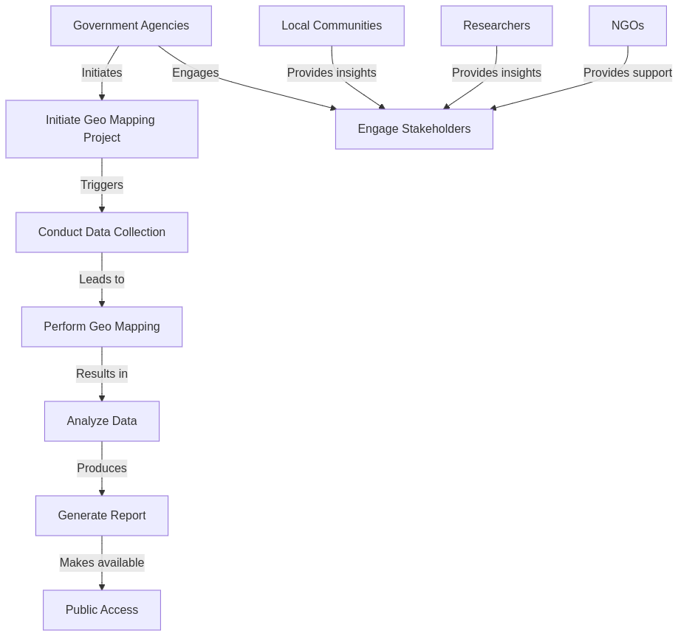

**Figure_003_intro_Use-case_Diagramly_Code:-**

flowchart TD

GovAgencies[Government Agencies] -->|Initiates| InitiateProject[Initiate Geo Mapping Project]

GovAgencies -->|Engages| Stakeholders[Engage Stakeholders]

LocalComm[Local Communities] -->|Provides insights| Stakeholders

Researchers[Researchers] -->|Provides insights| Stakeholders

NGOs[NGOs] -->|Provides support| Stakeholders

InitiateProject -->|Triggers| DataCollection[Conduct Data Collection]

DataCollection -->|Leads to| GeoMapping[Perform Geo Mapping]

GeoMapping -->|Results in| Analysis[Analyze Data]

Analysis -->|Produces| Report[Generate Report]

Report -->|Makes available| Access[Public Access]

**Used By (End Users):-** Planners, Decision makers, administrators, academicians, Farmers, and the public in general.

**Use Case for End Users:-**

#### 1. Actors

* Planners: Individuals responsible for developing agricultural policies and strategies.
* Decision Makers: Authorities who make final decisions regarding agricultural initiatives and resource allocation.
* Administrators: Personnel managing the agricultural data management system and ensuring its smooth operation.
* Academicians: Researchers and educators studying agricultural practices and contributing to knowledge dissemination.
* Farmers: Individuals engaged in agricultural activities who will use the system to improve their practices.
* Public: General population interested in agricultural sustainability and food security.

#### 2. Main Flow

1. Initiation: Planners identify the need for an agricultural data management system to enhance decision-making.
2. System Development: Administrators collaborate with technology providers to develop the system, incorporating input from academicians and farmers.
3. Data Collection: Farmers input data regarding crop yields, soil health, weather conditions, and pest occurrences into the system.
4. Data Analysis: The system analyzes the collected data to generate insights on best practices, crop rotation, and resource allocation.
5. Reporting: The system generates reports for decision-makers, highlighting trends, challenges, and recommendations for policy adjustments.
6. Public Access: The findings and recommendations are made available to the public, promoting transparency and awareness.
7. Feedback Loop: Farmers and the public provide feedback on the system's effectiveness, which is used to make continuous improvements.

#### 3. Alternative Flow

* Data Inaccuracy: If farmers input inaccurate data, the system prompts them for verification or provides guidelines for accurate data entry.
* Resistance to Technology: If farmers are resistant to using the system, additional training sessions and workshops are organized to demonstrate its benefits.
* Technical Issues: If the system experiences technical difficulties, administrators work with technology providers to resolve issues promptly.

#### 4. Benefits

* Informed Decision-Making: Provides planners and decision-makers with data-driven insights to formulate effective agricultural policies.
* Improved Agricultural Practices: Empowers farmers with knowledge and recommendations to enhance crop yields and sustainability.
* Increased Transparency: Ensures that the public has access to agricultural data and decision-making processes, fostering trust and engagement.
* Research and Education: Offers academicians valuable data for research and teaching, contributing to the advancement of agricultural science.

#### Pre-Conditions

* Government support and funding for the development of the agricultural data management system.
* Collaboration and willingness from farmers and stakeholders to participate in data collection and system usage.
* Availability of technology and infrastructure to support the system.

#### Post-Conditions

* A fully operational agricultural data management system is in place, accessible to all actors.
* Enhanced understanding of agricultural practices among farmers and decision-makers.
* Established frameworks for ongoing data collection, analysis, and policy adjustment based on insights gained from the system.

This use case outlines the interactions and benefits of an agricultural data management system involving various stakeholders, emphasizing the importance of collaboration and data-driven decision-making in agriculture.

**Figure_004_End-User_Use-case_PlantUML_Diagram:-**

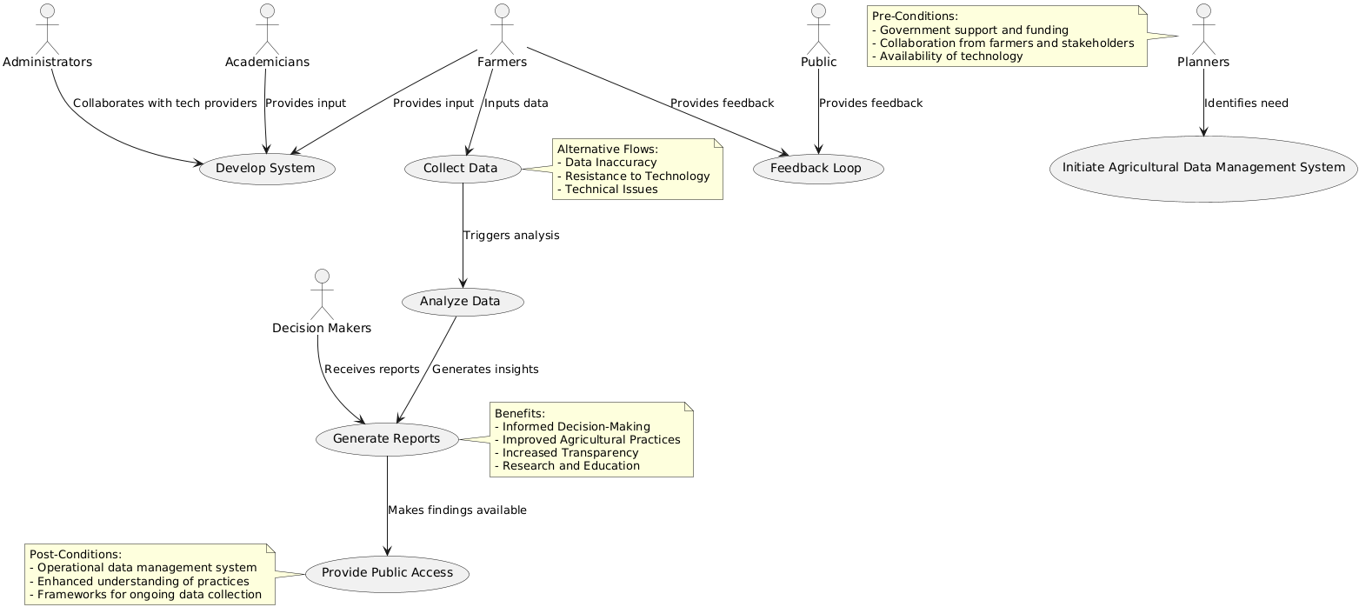

**Figure_004_End-User_Use-case_PlantUML_code:-**

@startuml

actor "Planners" as P

actor "Decision Makers" as DM

actor "Administrators" as A

actor "Academicians" as AC

actor "Farmers" as F

actor "Public" as PUB

usecase "Initiate Agricultural Data Management System" as UC1

usecase "Develop System" as UC2

usecase "Collect Data" as UC3

usecase "Analyze Data" as UC4

usecase "Generate Reports" as UC5

usecase "Provide Public Access" as UC6

usecase "Feedback Loop" as UC7

P --> UC1 : Identifies need

A --> UC2 : Collaborates with tech providers

AC --> UC2 : Provides input

F --> UC2 : Provides input

F --> UC3 : Inputs data

UC3 --> UC4 : Triggers analysis

UC4 --> UC5 : Generates insights

DM --> UC5 : Receives reports

UC5 --> UC6 : Makes findings available

F --> UC7 : Provides feedback

PUB --> UC7 : Provides feedback

note right of UC3

Alternative Flows:

- Data Inaccuracy

- Resistance to Technology

- Technical Issues

end note

note right of UC5

Benefits:

- Informed Decision-Making

- Improved Agricultural Practices

- Increased Transparency

- Research and Education

end note

note left of P

Pre-Conditions:

- Government support and funding

- Collaboration from farmers and stakeholders

- Availability of technology

end note

note left of UC6

Post-Conditions:

- Operational data management system

- Enhanced understanding of practices

- Frameworks for ongoing data collection

end note

@enduml

**Figure_005_End-User_Use-case_Notegpt_Diagram:-**

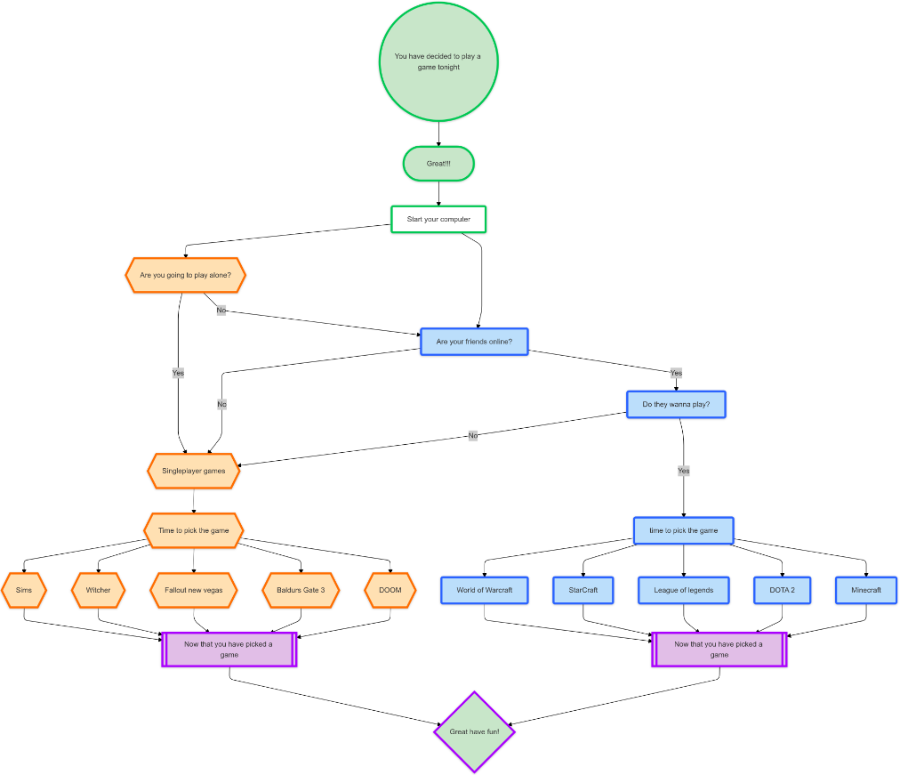

**Figure_005_End-User_Use-case_Notegpt_code:-**

@startuml

actor "Planners" as P

actor "Decision Makers" as DM

actor "Administrators" as A

actor "Academicians" as AC

actor "Farmers" as F

actor "Public" as PUB

usecase "Initiate Agricultural Data Management System" as UC1

usecase "Develop System" as UC2

usecase "Collect Data" as UC3

usecase "Analyze Data" as UC4

usecase "Generate Reports" as UC5

usecase "Provide Public Access" as UC6

usecase "Feedback Loop" as UC7

P --> UC1 : Identifies need

A --> UC2 : Collaborates with tech providers

AC --> UC2 : Provides input

F --> UC2 : Provides input

F --> UC3 : Inputs data

UC3 --> UC4 : Triggers analysis

UC4 --> UC5 : Generates insights

DM --> UC5 : Receives reports

UC5 --> UC6 : Makes findings available

F --> UC7 : Provides feedback

PUB --> UC7 : Provides feedback

note right of UC3

Alternative Flows:

- Data Inaccuracy

- Resistance to Technology

- Technical Issues

flowchart TD

GovAgencies[Government Agencies] -->|Initiates| InitiateProject[Initiate Geo Mapping Project]

GovAgencies -->|Engages| Stakeholders[Engage Stakeholders]

LocalComm[Local Communities] -->|Provides insights| Stakeholders

Researchers[Researchers] -->|Provides insights| Stakeholders

NGOs[NGOs] -->|Provides support| Stakeholders

InitiateProject -->|Triggers| DataCollection[Conduct Data Collection]

DataCollection -->|Leads to| GeoMapping[Perform Geo Mapping]

GeoMapping -->|Results in| Analysis[Analyze Data]

Analysis -->|Produces| Report[Generate Report]

Report -->|Makes available| Access[Public Access]end note

note right of UC5

Benefits:

- Informed Decision-Making

- Improved Agricultural Practices

- Increased Transparency

- Research and Education

end note

note left of P

Pre-Conditions:

- Government support and funding

- Collaboration from farmers and stakeholders

- Availability of technology

end note

note left of UC6

Post-Conditions:

- Operational data management system

- Enhanced understanding of practices

- Frameworks for ongoing data collection

end note

@enduml

**Figure_006_End-User_Use-case_Diagramly_Diagram:-**

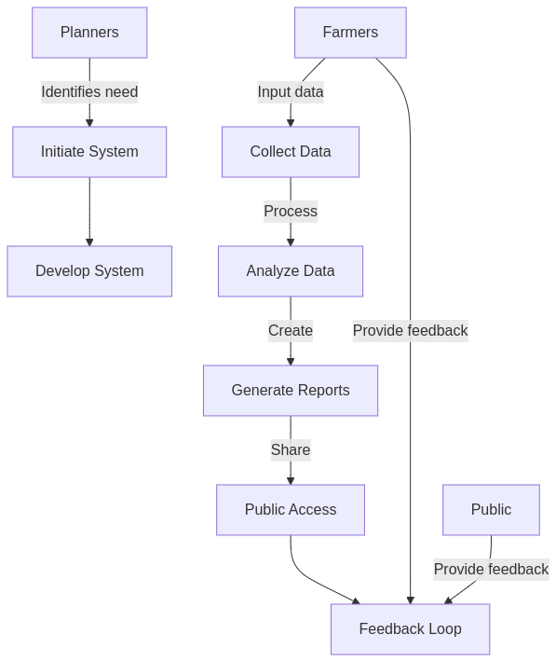

**Figure_006_End-User_Use-case_Diagramly_Code:-**

flowchart TD

Planners[Planners] -->|Identifies need| Init[Initiate System]

Init --> Develop[Develop System]

Farmers[Farmers] -->|Input data| Collect[Collect Data]

Collect -->|Process| Analyze[Analyze Data]

Analyze -->|Create| Reports[Generate Reports]

Reports -->|Share| Access[Public Access]

Access --> Feedback[Feedback Loop]

Farmers -->|Provide feedback| Feedback

Public[Public] -->|Provide feedback| Feedback

**Priority**:- **Low Priority-** this application is not interlinked With any DSS of the WARIMS portal.

**Description**:-

Priority: Low - This application is classified as low priority because it operates independently and is not integrated with any Decision Support System (DSS) within the WARIMS portal. As a result, it does not impact or rely on the functionalities of the DSS, allowing for a more flexible approach to its management and development.

**Reframe**:-

Priority: Low - This application is designated as low priority due to its independent operation, lacking integration with any Decision Support System (DSS) within the WARIMS portal. Consequently, it does not affect or depend on DSS functionalities, enabling a more adaptable approach to its management and development.

**Use Case**:- Independent Application Management

#### 1. Actors

* **User **: The individual who interacts with the application for data entry, retrieval, or reporting.
* System Administrator: The person responsible for maintaining the application, ensuring its performance, and managing updates.
* Support Team: The team that provides assistance and troubleshooting for users encountering issues with the application.

#### 2. Main Flow

1. User Access: The user logs into the application using their credentials.
2. Data Entry: The user inputs data into the application, which is stored independently of the DSS.
3. Data Retrieval: The user requests to view or generate reports based on the entered data.
4. System Processing: The application processes the request and retrieves the relevant data.
5. Output Generation: The application displays the requested information or generates a report for the user.
6. User Logout: The user logs out of the application after completing their tasks.

#### 3. Alternative Flow

* Invalid Login Attempt:
  + If the user enters incorrect credentials, the system displays an error message and prompts the user to re-enter their login information.
* Data Entry Error:
  + If the user inputs invalid data (e.g., incorrect format), the system alerts the user with an error message and allows them to correct the entry before proceeding.
* System Maintenance:
  + If the system administrator needs to perform maintenance, the application may be temporarily unavailable. Users will receive a notification about the downtime and an estimated time for when the application will be back online.

#### 4. Benefits

* Flexibility: The independent nature of the application allows for easier updates and modifications without affecting other systems.
* Reduced Complexity: Since it does not rely on the DSS, the application can be managed with fewer dependencies, simplifying troubleshooting and support.
* User Autonomy: Users can operate the application without needing to interact with the DSS, allowing for quicker access to data and reports.

#### Pre-Conditions

* The user must have valid login credentials to access the application.
* The application must be operational and accessible to users.

#### Post-Conditions

* The user successfully logs out of the application after completing their tasks.
* Any data entered or reports generated are saved and available for future access.
* The system administrator has the ability to monitor application performance and user activity for maintenance purposes.

**Figure_021_Priority_Use-case_Plantuml_Diagram:-**

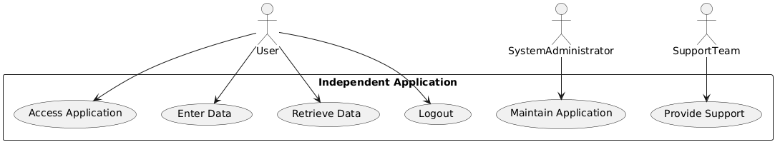

**Figure_021_Priority_Use-case_Plantuml_Code:-**

@startuml

actor User

actor SystemAdministrator

actor SupportTeam

rectangle "Independent Application" {

User --> (Access Application)

User --> (Enter Data)

User --> (Retrieve Data)

User --> (Logout)

SystemAdministrator --> (Maintain Application)

SupportTeam --> (Provide Support)

}

@enduml

**Figure_022_Priority_Use-case_Notegpt_Diagram:-**

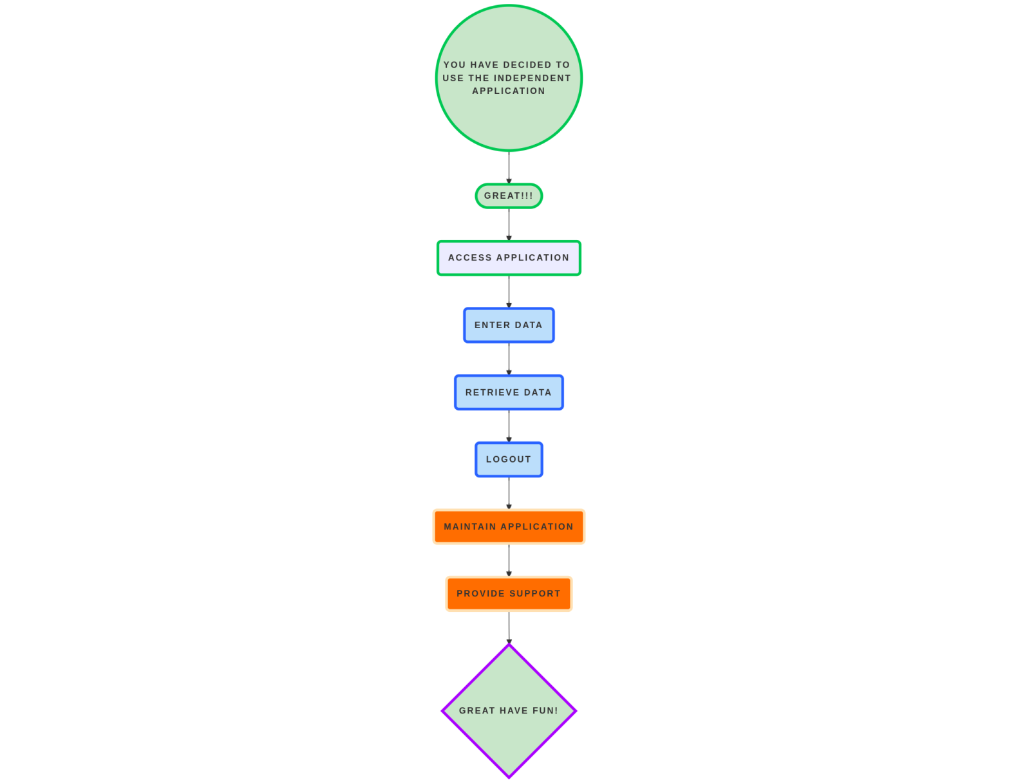

**Figure_022_Priority_Use-case_Notegpt_Code:-**

@startuml

actor User

actor SystemAdministrator

actor SupportTeam

rectangle "Independent Application" {

User --> (Access Application)

User --> (Enter Data)

User --> (Retrieve Data)

User --> (Logout)

SystemAdministrator --> (Maintain Application)

SupportTeam --> (Provide Support)

}

@endum

**Figure_023_Priority_Use-case_Diagramly_Diagram:-**

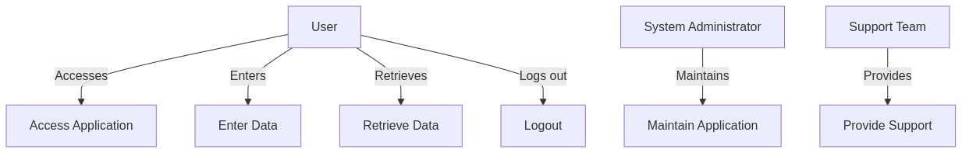

**Figure_023_Priority_Use-case_Diagramly_Code:-**

%%{ init : { "theme" : "default" } }%%

graph TD

User[User ] -->|Accesses| A[Access Application]

User -->|Enters| B[Enter Data]

User -->|Retrieves| C[Retrieve Data]

User -->|Logs out| D[Logout]

SystemAdministrator[System Administrator] -->|Maintains| E[Maintain Application]

SupportTeam[Support Team] -->|Provides| F[Provide Support]

**Phase:-Phase 1**

**Governance Need (Business Problem):-**

**Issue**:- Data received from State and Central Agencies are in the .pdf format which can not be directly incorporated in the database. Multiple heritage structures are shown on a same point. Data will be manipulated on various boundaries for better visualization.

**Reframe**:-

Issue: The data received from State and Central Agencies is in PDF format, which cannot be directly integrated into the database. Additionally, multiple heritage structures are represented at the same location, necessitating data manipulation across various boundaries for improved visualization.

### Use Case: Data Integration and Visualization for Heritage Structures

#### 1. Actors

* Data Analysts: Individuals responsible for processing and analyzing data from various sources.
* Database Administrators: Personnel managing the database and ensuring data integrity and accessibility.
* Heritage Conservationists: Experts focused on preserving and managing heritage structures.
* Technology Providers: Companies or organizations that provide tools and software for data conversion and visualization.
* Decision Makers: Authorities who utilize the visualized data for planning and decision-making.

#### 2. Main Flow

1. Data Collection: Data Analysts receive heritage structure data from State and Central Agencies in PDF format.
2. Data Conversion: The Data Analysts use specialized software to convert the PDF data into a structured format (e.g., CSV or Excel) that can be imported into the database.
3. Data Cleaning: The converted data is cleaned to remove any inconsistencies or errors that may have occurred during the conversion process.
4. Data Integration: The cleaned data is imported into the database, ensuring that it is properly structured and accessible.
5. Data Visualization: The Data Analysts manipulate the data to address instances where multiple heritage structures are represented at the same location, applying various boundaries for better visualization.
6. Report Generation: Visualized data is compiled into reports that highlight the distribution and status of heritage structures.
7. Decision Support: Decision Makers review the reports and visualizations to inform planning and conservation efforts.

#### 3. Alternative Flow

* Conversion Errors: If errors occur during the PDF to structured format conversion, Data Analysts will troubleshoot the issues and may need to manually extract data from the PDFs.
* Data Duplication: If multiple entries for the same heritage structure are found, Data Analysts will consolidate the data to ensure accuracy and prevent duplication.
* Technical Issues: If there are technical difficulties with the software used for data conversion or visualization, the Technology Providers will be contacted for support.

#### 4. Benefits

* Improved Data Accessibility: Converting PDF data into a structured format allows for easier access and manipulation of information.
* Enhanced Visualization: By addressing overlapping data points, stakeholders can gain clearer insights into the distribution of heritage structures.
* Informed Decision-Making: Decision Makers can make better-informed choices regarding heritage conservation and management based on accurate and visualized data.

#### Pre-Conditions

* Availability of software tools for PDF conversion and data visualization.
* Collaboration from State and Central Agencies to provide accurate and complete data.
* Technical expertise among Data Analysts to handle data conversion and manipulation.

#### Post-Conditions

* A structured database containing accurate and accessible data on heritage structures.
* Visualized reports that effectively communicate the status and distribution of heritage structures to stakeholders.
* Established processes for ongoing data integration and visualization to keep the database current and useful for decision-making.

This use case outlines the process of integrating and visualizing data from State and Central Agencies, addressing the challenges posed by PDF formats and overlapping data points for heritage structures.

**Summary:-**

The use case outlines the process of integrating and visualizing heritage structure data received from State and Central Agencies, which is initially in PDF format and requires conversion for database integration. Key actors include data analysts, database administrators, heritage conservationists, technology providers, and decision-makers. The main flow involves collecting data, converting it into a structured format, cleaning it for accuracy, integrating it into a database, and visualizing it to address instances of multiple structures at the same location. The process also includes generating reports for decision-makers to support informed planning and conservation efforts. Challenges such as conversion errors and data duplication are addressed, and the benefits include improved data accessibility, enhanced visualization, and better-informed decision-making. Preconditions for success include the availability of software tools and collaboration from agencies, while post-conditions ensure a structured database and ongoing processes for data management.

**Figure_007_Govt. Need _Use-case_Plantuml_Diagram:-**

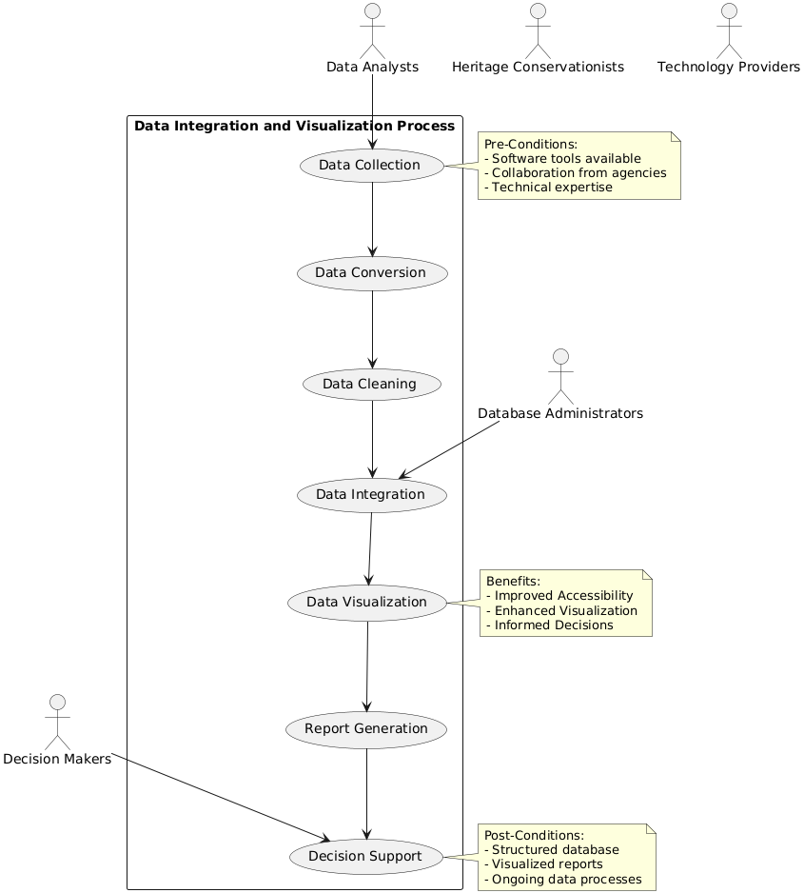

**Figure_007_Govt. Need _Use-case_Plantuml_Code:-**

@startuml

actor "Data Analysts" as DA

actor "Database Administrators" as DBA

actor "Heritage Conservationists" as HC

actor "Technology Providers" as TP

actor "Decision Makers" as DM

rectangle "Data Integration and Visualization Process" {

(Data Collection) --> (Data Conversion)

(Data Conversion) --> (Data Cleaning)

(Data Cleaning) --> (Data Integration)

(Data Integration) --> (Data Visualization)

(Data Visualization) --> (Report Generation)

(Report Generation) --> (Decision Support)

}

DA --> (Data Collection)

DBA --> (Data Integration)

DM --> (Decision Support)

note right of (Data Collection)

Pre-Conditions:

- Software tools available

- Collaboration from agencies

- Technical expertise

end note

note right of (Decision Support)

Post-Conditions:

- Structured database

- Visualized reports

- Ongoing data processes

end note

note left of (Data Visualization)

Benefits:

- Improved Accessibility

- Enhanced Visualization

- Informed Decisions

end note

@enduml

**Figure_008_Govt. Need _Use-case_Notegpt_Diagram:-**

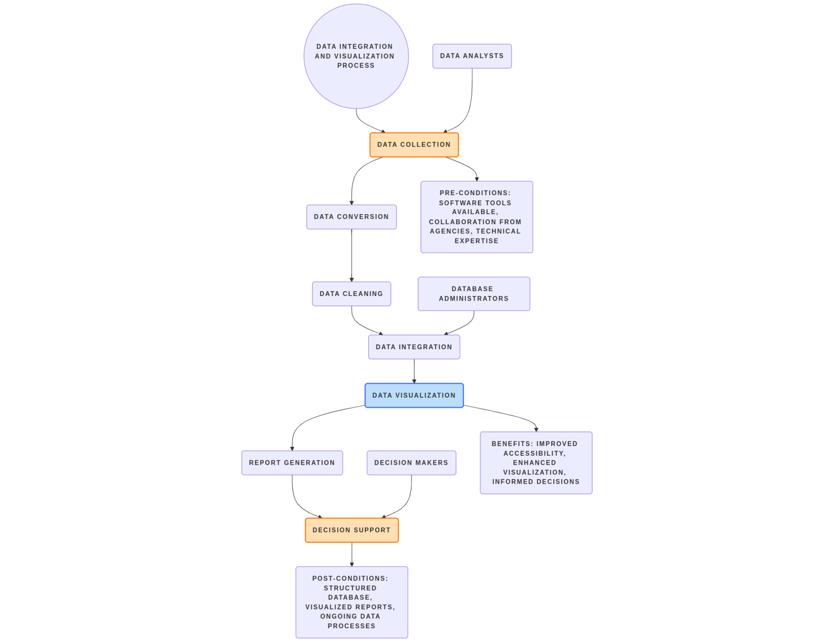

**Figure_008_Govt. Need _Use-case_Notegpt_Code:-**

@startuml

actor "Data Analysts" as DA

actor "Database Administrators" as DBA

actor "Heritage Conservationists" as HC

actor "Technology Providers" as TP

actor "Decision Makers" as DM

rectangle "Data Integration and Visualization Process" {

(Data Collection) --> (Data Conversion)

(Data Conversion) --> (Data Cleaning)

(Data Cleaning) --> (Data Integration)

(Data Integration) --> (Data Visualization)

(Data Visualization) --> (Report Generation)

(Report Generation) --> (Decision Support)

}

DA --> (Data Collection)

DBA --> (Data Integration)

DM --> (Decision Support)

note right of (Data Collection)

Pre-Conditions:

- Software tools available

- Collaboration from agencies

- Technical expertise

end note

note right of (Decision Support)

Post-Conditions:

- Structured database

- Visualized reports

- Ongoing data processes

end note

note left of (Data Visualization)

Benefits:

- Improved Accessibility

- Enhanced Visualization

- Informed Decisions

end note

@enduml

**Figure_009_Govt. Need _Use-case_Diagramly_Diagram:-**

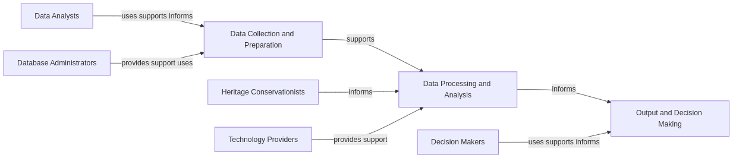

**Figure_009_Govt. Need _Use-case_Diagramly_Code:-**

flowchart LR

%% Main Stakeholders

DataAnalysts[Data Analysts]

DBAdmins[Database Administrators]

Heritage[Heritage Conservationists]

Tech[Technology Providers]

Decision[Decision Makers]

%% Main Process Blocks

Collection[Data Collection and Preparation]

Processing[Data Processing and Analysis]

Output[Output and Decision Making]

%% Relationships

DataAnalysts -->|uses supports informs| Collection

DBAdmins -->|provides support uses| Collection

Collection -->|supports| Processing

Heritage -->|informs| Processing

Tech -->|provides support| Processing

Processing -->|informs| Output

Decision -->|uses supports informs| Output

**Approach**:- The location of water heritage sites should be in proper geospatial format which need to validated with Ground Control Points for proper visualization.

**Output:-**

**Expected Outcome:-** Jal ltihaas will provide a comprehensive view of water heritage structures of the country, allowing for a better understanding of their historical significance and importance.

**Figure_010_Expected Outcome_Plantuml_Diagram:-**

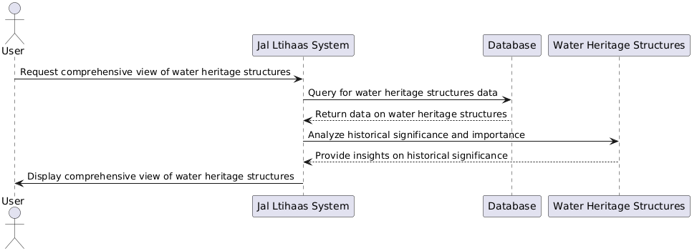

**Figure_010_Expected Outcome_Plantuml_Code:-**

@startuml

actor User

participant "Jal Ltihaas System" as JLS

participant "Database" as DB

participant "Water Heritage Structures" as WHS

User -> JLS: Request comprehensive view of water heritage structures

JLS -> DB: Query for water heritage structures data

DB --> JLS: Return data on water heritage structures

JLS -> WHS: Analyze historical significance and importance

WHS --> JLS: Provide insights on historical significance

JLS -> User: Display comprehensive view of water heritage structures

@enduml

**Figure_011_Expected Outcome_Notegpt_Diagram:-**

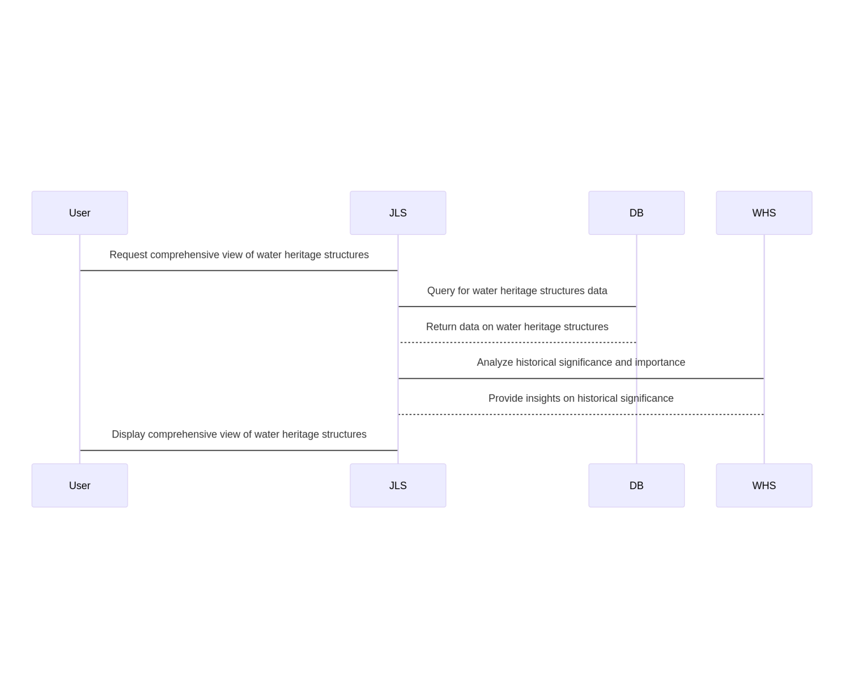

**Figure_011_Expected Outcome_Notegpt_Code:-**

@startuml

actor User

participant "Jal Ltihaas System" as JLS

participant "Database" as DB

participant "Water Heritage Structures" as WHS

User -> JLS: Request comprehensive view of water heritage structures

JLS -> DB: Query for water heritage structures data

DB --> JLS: Return data on water heritage structures

JLS -> WHS: Analyze historical significance and importance

WHS --> JLS: Provide insights on historical significance

JLS -> User: Display comprehensive view of water heritage structures

@enduml

**Figure_012_Expected Outcome_Diagramly_Diagram:-**

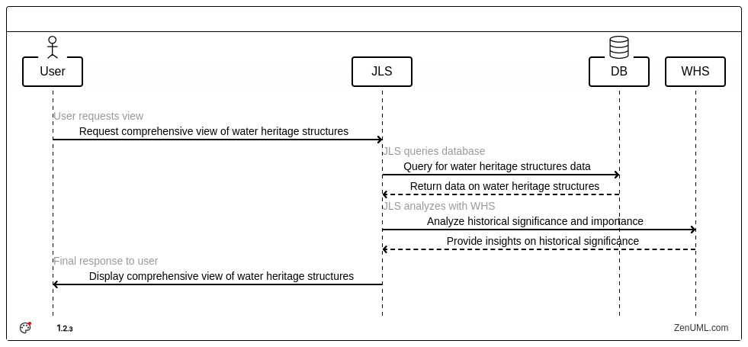

**Figure_012_Expected Outcome_Diagramly_Code:-**

@Actor "User"

@System "JLS"

@Database "DB"

@System "WHS"

// User requests view

"User" ->"JLS": Request comprehensive view of water heritage structures

// JLS queries database

"JLS" ->"DB": Query for water heritage structures data

@return "DB" ->"JLS": Return data on water heritage structures

// JLS analyzes with WHS

"JLS" ->"WHS": Analyze historical significance and importance

@return "WHS" ->"JLS": Provide insights on historical significance

// Final response to user@startuml

actor User

participant "Jal Ltihaas System" as JLS

participant "Database" as DB

participant "Water Heritage Structures" as WHS

User -> JLS: Request comprehensive view of water heritage structures

JLS -> DB: Query for water heritage structures data

DB --> JLS: Return data on water heritage structures

JLS -> WHS: Analyze historical significance and importance

WHS --> JLS: Provide insights on historical significance

JLS -> User: Display comprehensive view of water heritage structures

@enduml

"JLS" ->"User": Display comprehensive view of water heritage structures

**Visualization:-**

**1. Map:** Geolocation of water heritage sites in the country will be shown with respect to;

* **Political Boundaries**
* **State**
* **District**

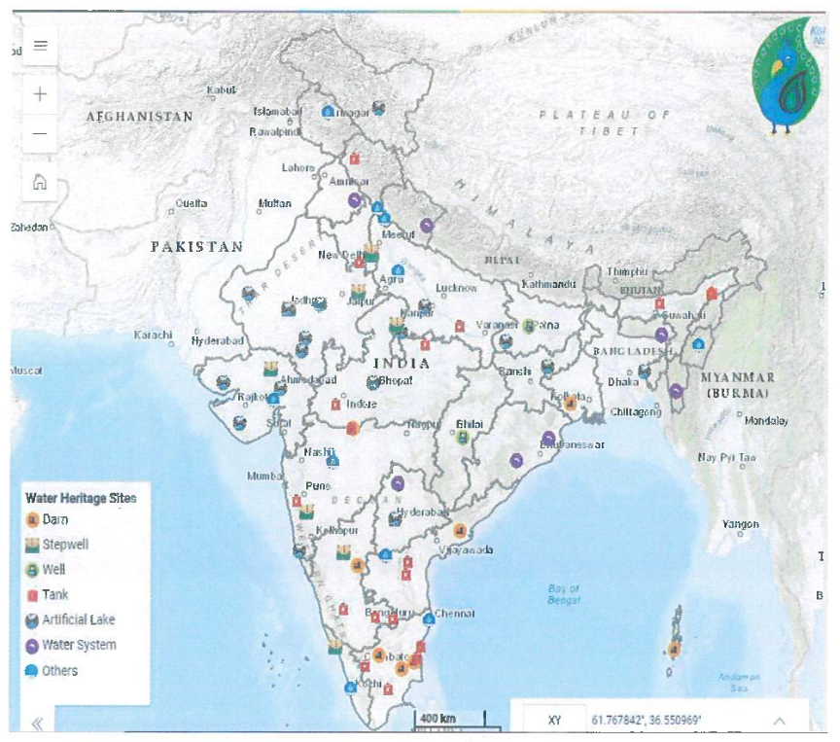

(A). Water Heritage Structures at India Level

**User Selection:**When the user clicks on the location of water heritage site in an application, the below mention table will pop-up on the screen with key salient features of the heritage sites so that the user can easily identify them.

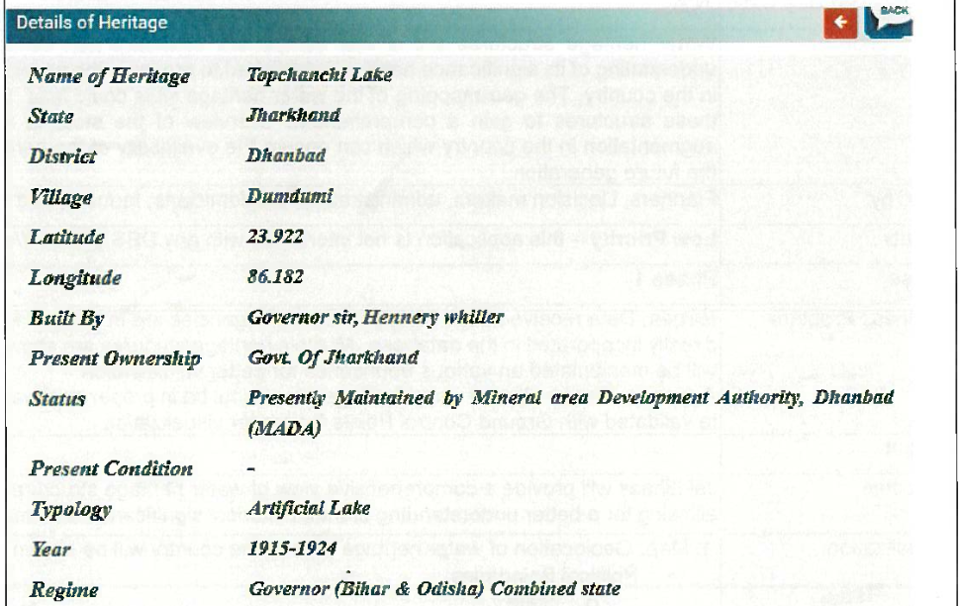

**Figure_013_Visualization_Plantuml_Diagram:-**

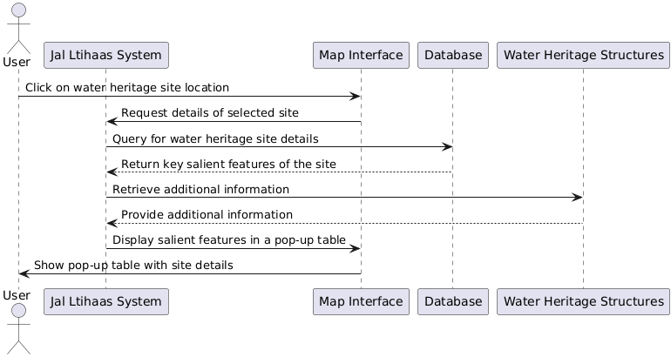

**Figure_013_Visualization_Plantuml_Code:-**

@startuml

actor User

participant "Jal Ltihaas System" as JLS

participant "Map Interface" as Map

participant "Database" as DB

participant "Water Heritage Structures" as WHS

User -> Map: Click on water heritage site location

Map -> JLS: Request details of selected site

JLS -> DB: Query for water heritage site details

DB --> JLS: Return key salient features of the site

JLS -> WHS: Retrieve additional information

WHS --> JLS: Provide additional information

JLS -> Map: Display salient features in a pop-up table

Map -> User: Show pop-up table with site details

@enduml

**Figure_014_Visualization_Notegpt_Diagram:-**

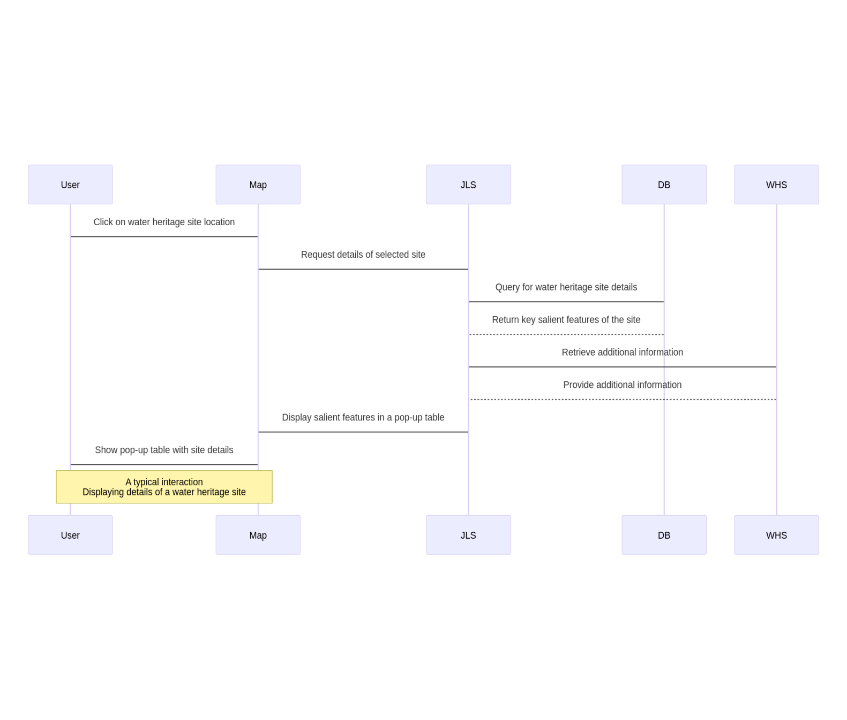

**Figure_014_Visualization_Notegpt_Code:-**

@startuml

actor User

participant "Jal Ltihaas System" as JLS

participant "Map Interface" as Map

participant "Database" as DB

participant "Water Heritage Structures" as WHS

User -> Map: Click on water heritage site location

Map -> JLS: Request details of selected site

JLS -> DB: Query for water heritage site details

DB --> JLS: Return key salient features of the site

JLS -> WHS: Retrieve additional information

WHS --> JLS: Provide additional information

JLS -> Map: Display salient features in a pop-up table

Map -> User: Show pop-up table with site details

@enduml

**2. Graph / Charts:**

(X-Axis : State name, Y-Axis: Count of water heritage sites)

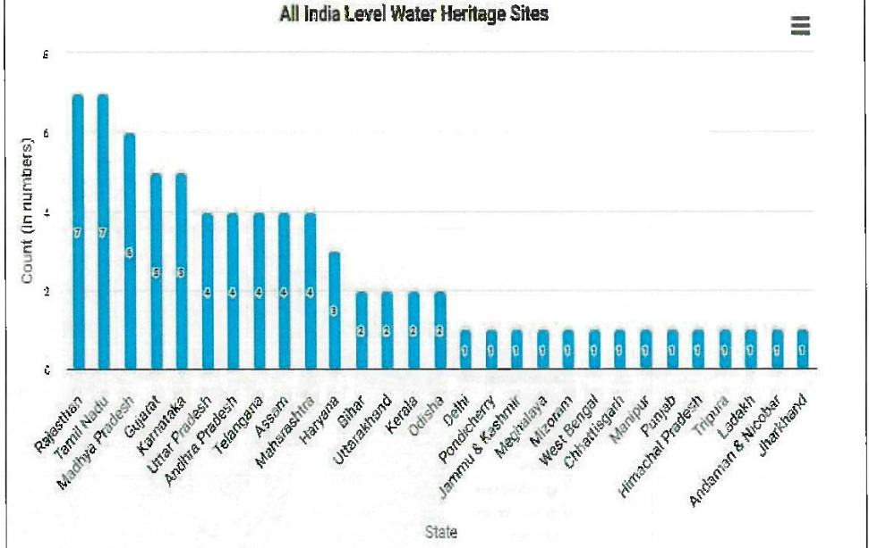

**3.Output on Tabular Form**

|  |  |  |  |  |  |
| --- | --- | --- | --- | --- | --- |
| **Sr.No** | **Heritage Name** | **State** | **District** | **Type** | **Year** |
| 1 | Panighat Aqueduct | Andaman & Nicobar | South Andamans | Dam | During British Period |
| 2 | k.c.canal Aqueduct Across Handri River | Andhra Pradesh | Kurnool | Others | 19th Century |
| 3 | Sir Arthur Cotton Barrage (Dholeshwaram Anicut) | Andhra Pradesh | East Godavari | Dam | 1852 |
| 4 | Porumamilla Tank (Anantharaja sagaram) | Andhra Pradesh | YSR Kadapa | Tank | 1869 |
| 5 | Cumbum Tank | Andhra Pradesh | Prakasham | Tank | 1522-1524 AD |
| 6 | Bor Pukari or Sivasagar Tank | Assam | Sivasagar | Tank | 1734 |

**Figure_015_Visualization_Plantuml_Diagram:-**

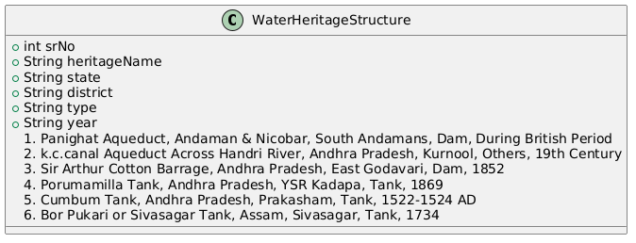

**Figure_015_Visualization_Plantuml_Code:-**

@startuml

class WaterHeritageStructure {

+int srNo

+String heritageName

+String state

+String district

+String type

+String year

}

WaterHeritageStructure : 1. Panighat Aqueduct, Andaman & Nicobar, South Andamans, Dam, During British Period

WaterHeritageStructure : 2. k.c.canal Aqueduct Across Handri River, Andhra Pradesh, Kurnool, Others, 19th Century

WaterHeritageStructure : 3. Sir Arthur Cotton Barrage, Andhra Pradesh, East Godavari, Dam, 1852

WaterHeritageStructure : 4. Porumamilla Tank, Andhra Pradesh, YSR Kadapa, Tank, 1869

WaterHeritageStructure : 5. Cumbum Tank, Andhra Pradesh, Prakasham, Tank, 1522-1524 AD

WaterHeritageStructure : 6. Bor Pukari or Sivasagar Tank, Assam, Sivasagar, Tank, 1734

@enduml

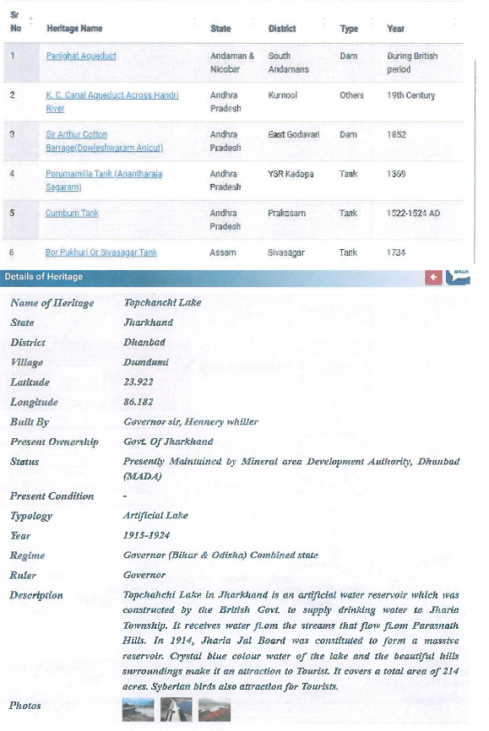

**Frequency of Up-dation:-**Static in Nature, However, data Will be updated as per their availability.

**Reframe**:-

Frequency of Up-dation:-

The frequency of updates is inherently static, meaning that the data will not change on a regular schedule. Instead, updates will occur based on the availability of new information.

This approach allows for a more flexible and responsive system, ensuring that the data remains relevant and accurate as new insights or information become accessible.

While users can expect a consistent baseline of information, they should also be aware that updates will be implemented as opportunities arise, enhancing the overall quality and reliability of the data provided.

**Measure of Success:-** The application shows a comprehensive view of water heritage structures, allowing for a better (KPIls) understanding of their historical significance and importance.

**Input Data Required:-**

|  |  |  |  |  |
| --- | --- | --- | --- | --- |
| **Sr. No** | **Data point** | **Type** | **Unit** | **Data Provider** |
| 1 | Name of Heritage | String | Text | **National Water Mission** |
| 2 | Latitude | Float | Degree Decimal |
| 3 | Longitude | Float | Degree Decimal |
| 4 | Region | String | Text |
| 5 | State | String | Text |
| 6 | District | String | Text |
| 7 | Village | String | Text |
| 8 | Built by | String | Text |
| 9 | Present ownership | String | Text |
| 10 | Status | String | Text |
| 11 | Present Condition | String | Text |
| 12 | Topology | String | Text |
| 13 | Year | String | Text |
| 14 | Regime | String | Text |
| 15 | Ruler | String | Text |
| 16 | Photographs | String | hyperlink |

**Figure_016_Visualization_Plantuml_Diagram:-**

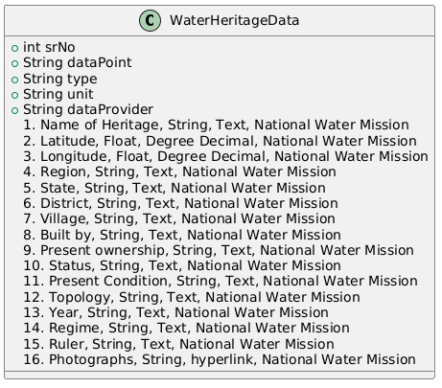

**Figure_016_Visualization_Plantuml_Code:-**

@startuml

class WaterHeritageData {

+int srNo

+String dataPoint

+String type

+String unit

+String dataProvider

}

WaterHeritageData : 1. Name of Heritage, String, Text, National Water Mission

WaterHeritageData : 2. Latitude, Float, Degree Decimal, National Water Mission

WaterHeritageData : 3. Longitude, Float, Degree Decimal, National Water Mission

WaterHeritageData : 4. Region, String, Text, National Water Mission

WaterHeritageData : 5. State, String, Text, National Water Mission

WaterHeritageData : 6. District, String, Text, National Water Mission

WaterHeritageData : 7. Village, String, Text, National Water Mission

WaterHeritageData : 8. Built by, String, Text, National Water Mission

WaterHeritageData : 9. Present ownership, String, Text, National Water Mission

WaterHeritageData : 10. Status, String, Text, National Water Mission

WaterHeritageData : 11. Present Condition, String, Text, National Water Mission

WaterHeritageData : 12. Topology, String, Text, National Water Mission

WaterHeritageData : 13. Year, String, Text, National Water Mission

WaterHeritageData : 14. Regime, String, Text, National Water Mission

WaterHeritageData : 15. Ruler, String, Text, National Water Mission

WaterHeritageData : 16. Photographs, String, hyperlink, National Water Mission

@enduml

**Process:**

**Algorithm/Tools:-**

Representation of Water heritage Structures on map and heritage Information on the users defined queries).

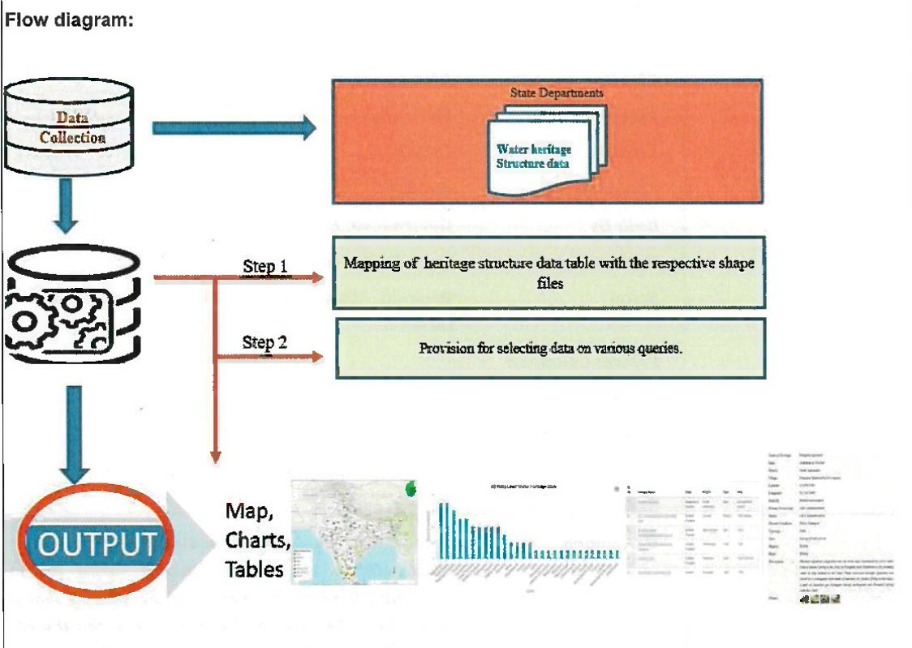

**flowchart TD**

**Start([Water Heritage Site]) --> HeritageName[Heritage Name]**

**HeritageName --> Location[State and District]**

**Location --> Type[Type of Structure]**

**Type --> Year[Construction Year]**

**HeritageName -->|Examples| Aqueduct[Panighat Aqueduct KC Canal]**

**HeritageName -->|Examples| Barrage[Sir Arthur Cotton Barrage]**

**HeritageName -->|Examples| Tank[Porumamilla Tank Cumbum Tank]**

**Location -->|States| States[Andaman and Nicobar Andhra Pradesh Assam]**

**Location -->|Districts| Districts[South Andamans Kurnool East Godavari]**

**Type -->|Categories| Structure[Dam Tank Others]**

**Year -->|Time Periods| Period[British Period 19th Century 1522-1524 AD]**

**Step 1:**Mapping of heritage Structure data table with the respective shape files.

**Step 2:**Provision for selecting data on various Queries.

**Data Validation:-**Water heritage Structures Information data may require validation before use.

**Software Technologies:-** QGIS, Python, Angular

**Dependencies & Risks:**Data availability With Source agencies.

**User Acceptance Testing (UAT):-** NWIC

**Development Responsibility:** NWIC

**Figure_017_Algorithm_Plantuml_Diagram:-**

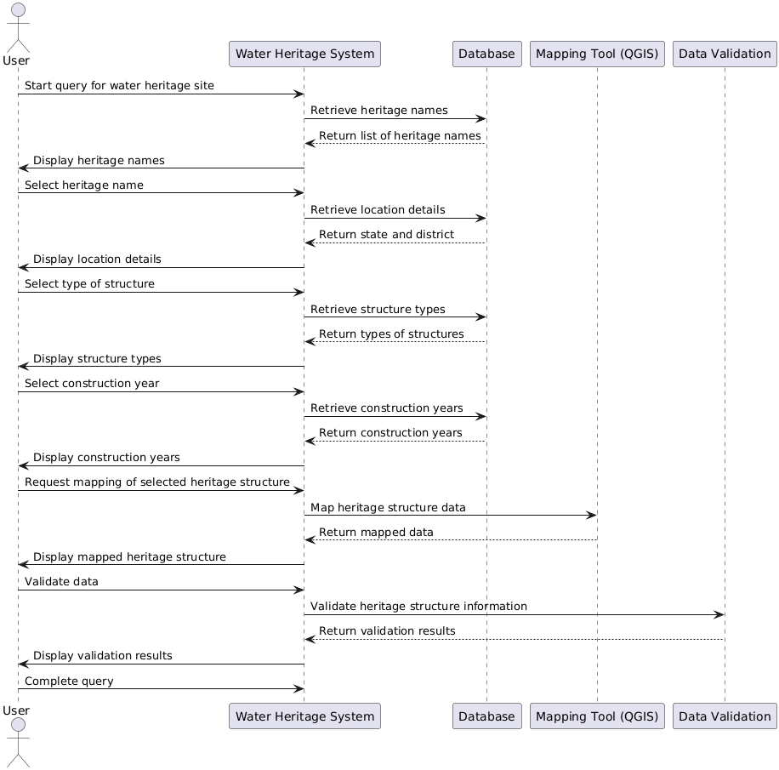

**Figure_017_Algorithm_Plantuml_Code:-**

@startuml

actor User

participant "Water Heritage System" as WHS

participant "Database" as DB

participant "Mapping Tool (QGIS)" as QGIS

participant "Data Validation" as DV

User -> WHS: Start query for water heritage site

WHS -> DB: Retrieve heritage names

DB --> WHS: Return list of heritage names

WHS -> User: Display heritage names

User -> WHS: Select heritage name

WHS -> DB: Retrieve location details

DB --> WHS: Return state and district

WHS -> User: Display location details

User -> WHS: Select type of structure

WHS -> DB: Retrieve structure types

DB --> WHS: Return types of structures

WHS -> User: Display structure types

User -> WHS: Select construction year

WHS -> DB: Retrieve construction years

DB --> WHS: Return construction years

WHS -> User: Display construction years

User -> WHS: Request mapping of selected heritage structure

WHS -> QGIS: Map heritage structure data

QGIS --> WHS: Return mapped data

WHS -> User: Display mapped heritage structure

User -> WHS: Validate data

WHS -> DV: Validate heritage structure information

DV --> WHS: Return validation results

WHS -> User: Display validation results

User -> WHS: Complete query

@enduml

**References :-** <https://indiawris.gov.in/wris/#/jalithihaas>

**---End of Document---**